**Important:**

**Once the configuration is complete, please ensure that the Laptop and Google Glass are in the same wi-fi network as that of Drone**

**Step-1:**

Ensure that the environment variables – ANDROID_HOME, JAVA_HOME, NODE_HOME, PATH variables are correctly set in System properties.

If Android is installed in C drive, set ANDROID_HOME variable as Android SDK path

Example: C:\AndroidSdk\adt-bundle-windows-x86-20140702\sdk

If Java is installed in C drive, set JAVA_HOME variable as JDK path

Example: C:\Program Files\Java\jdk1.7.0_65

If Node is installed in C drive, set NODE_HOME variable as nodejs installation path

Example: C:\Program Files\nodejs

Set PATH variable as

%NODE_HOME%;%ANDROID_HOME%\platform-tools; %ANDROID_HOME%\tools;%JAVA_HOME%\bin;

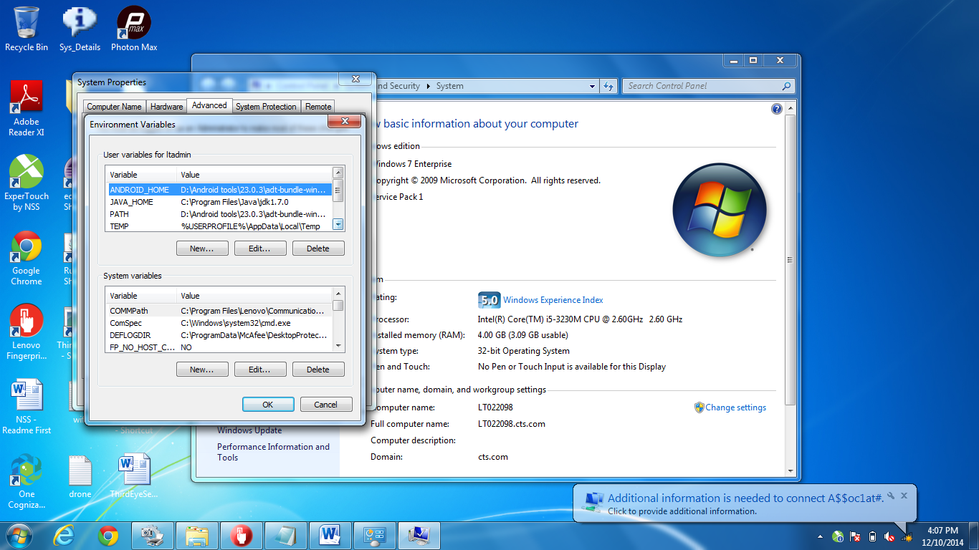

**Step -2:** Switch on the Drone. [Have the drone battery fully charged].

**Step-3:**

* Connect to the Drone WiFi.
* Go to Command Prompt and type “ipconfig” to check the IP Address.

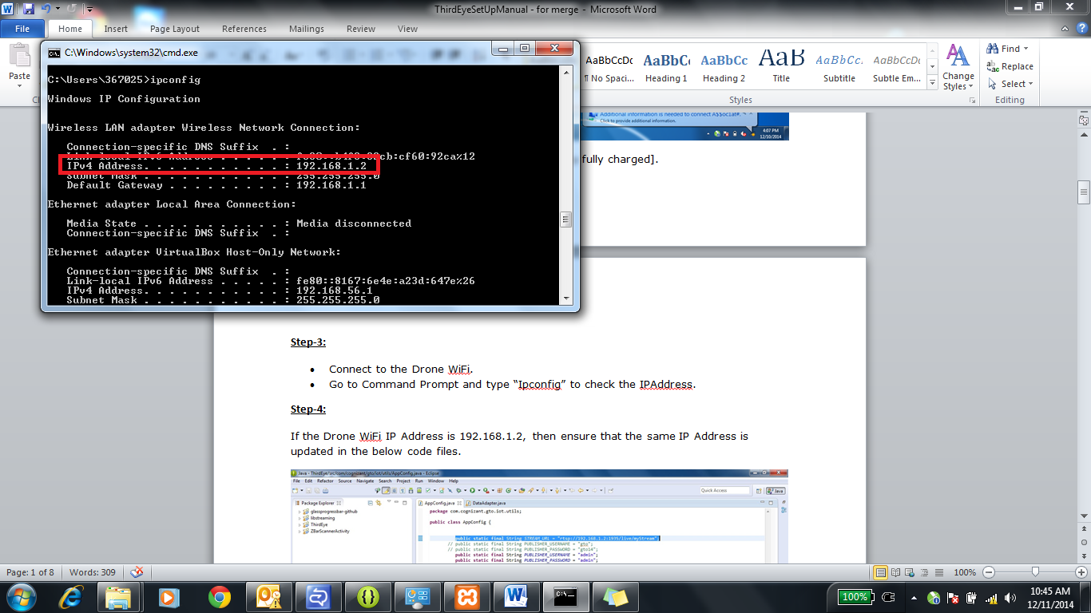

**Step-4:**

If the Drone wi-fi IP address is 192.168.1.2, then ensure that the same IP address is updated in the below code files.

1. AppConfig.java
2. DataAdapter.java

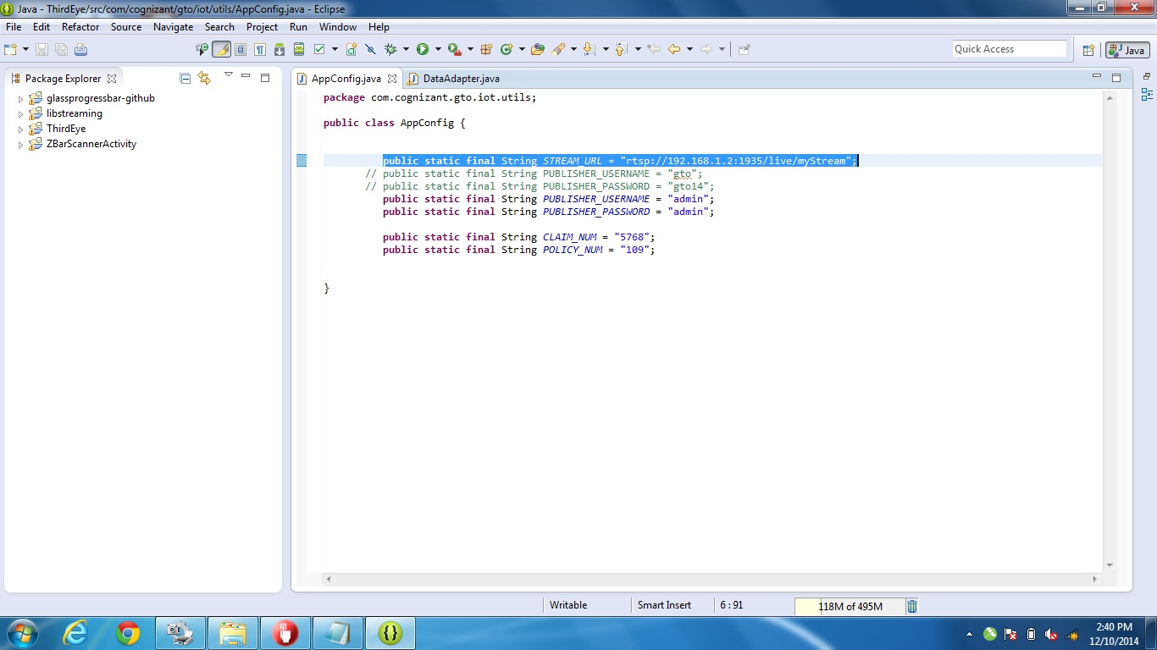

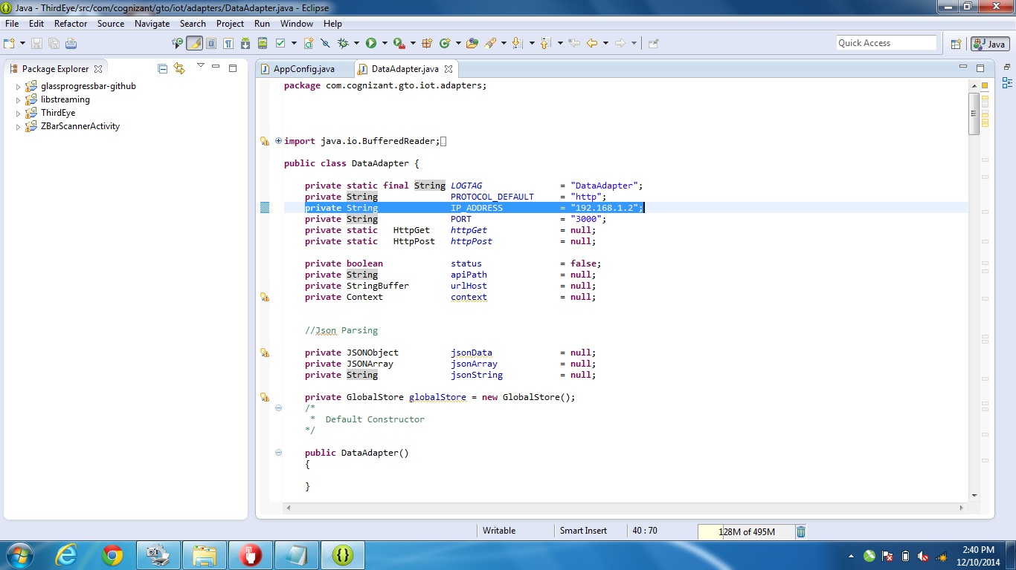

After doing the above mentioned changes, build the android project and install the apk into the Google Glass.

**Note: Currently we observe that there are 2 IP possibilities, either 192.168.1.2 or 192.168.1.3. So we have built 2 apks handy, ThirdEye.apk with 192.168.1.2 and ThirdEye1.APK 192.168.1.3. Please check the ipconfig as in step 3 and then decide whether you can use one of these apks or to rebuild the apk after making the changes in source files as detailed in this step.**

Open the index file from the path inside the ‘public’ folder and edit the IP address (as per the Drone’s IP address)

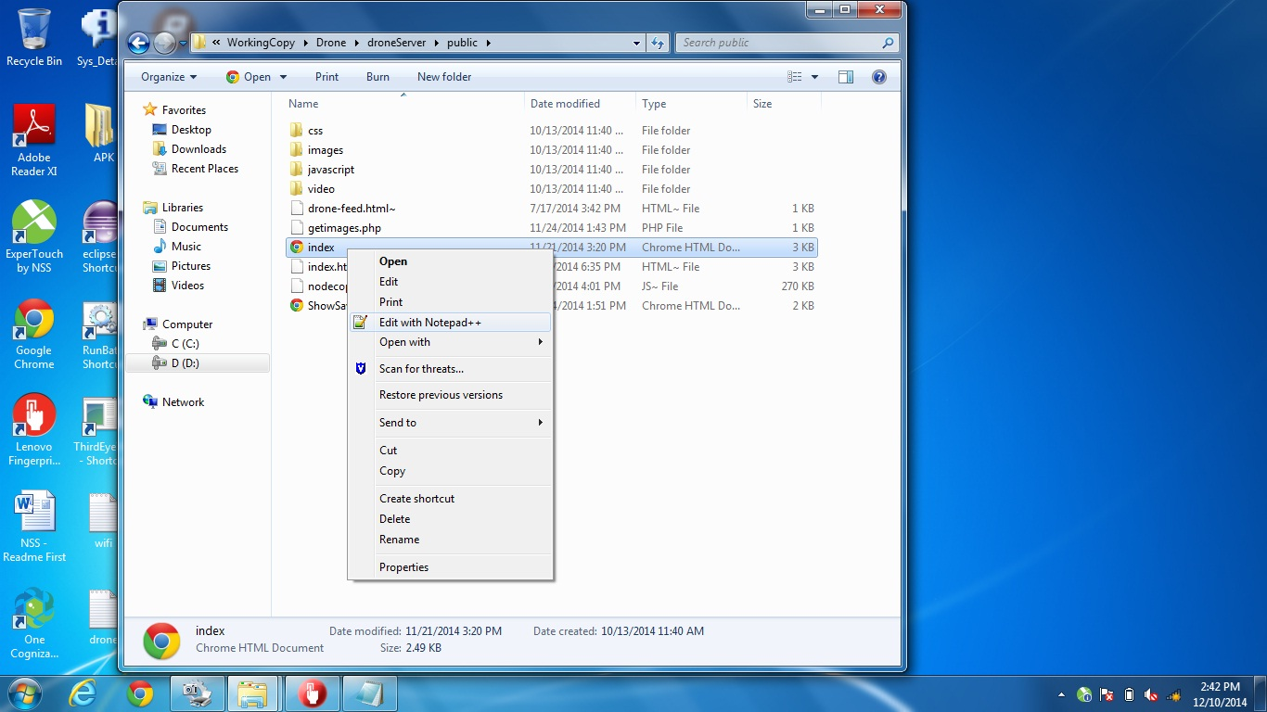

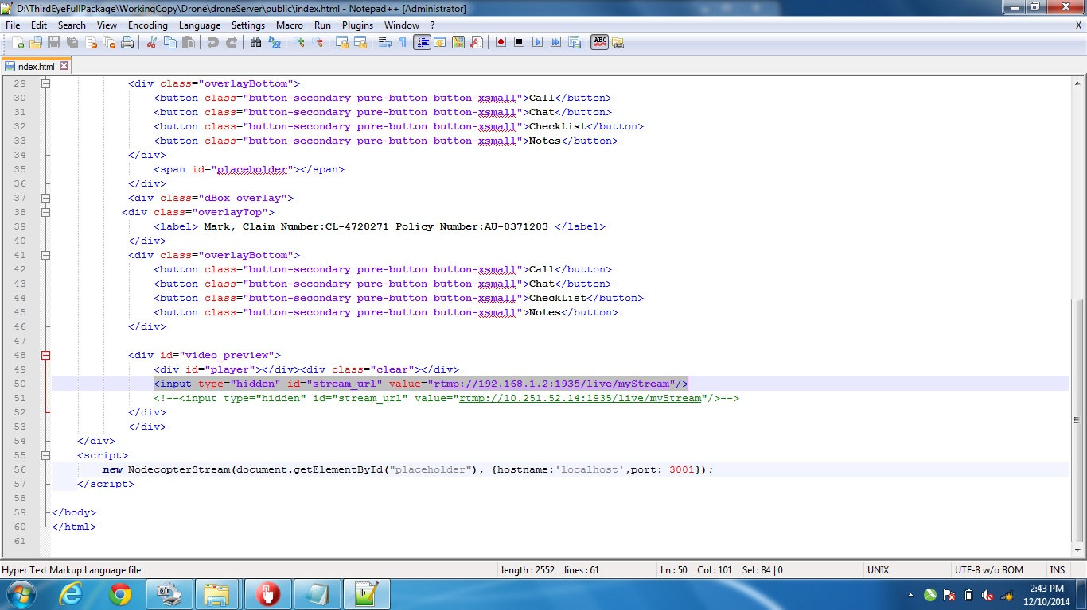

Ensure that you have installed Wowza Streaming Engine in your machine. Set up the Wowza Publisher with the user id set as “admin” and the password set as “admin”.

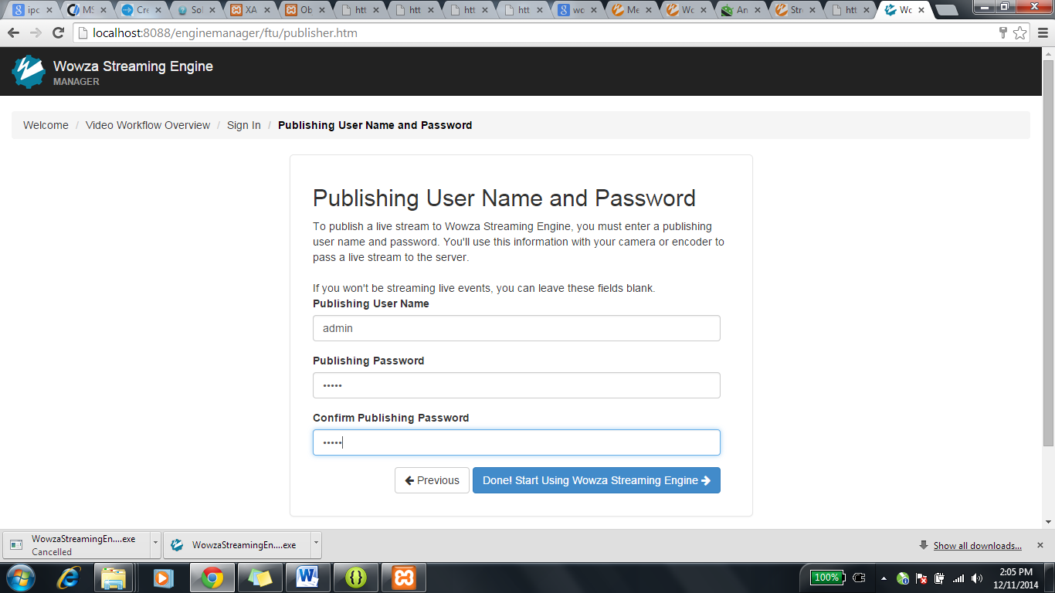

Now that the code and the machine set up are done, next step is to start with the demo.

**Step-5:**

Run the batch file for starting node server. Before running the batch file open the batch file verify the node installation path.

Batch File Location: (Locate RunBat.bat in the extracted folder path)

Example: C:\ThirdEye\Drone\droneServer\RunBat.bat

**Alternately, you can do the below step**

Start the node Js service, as mentioned below.

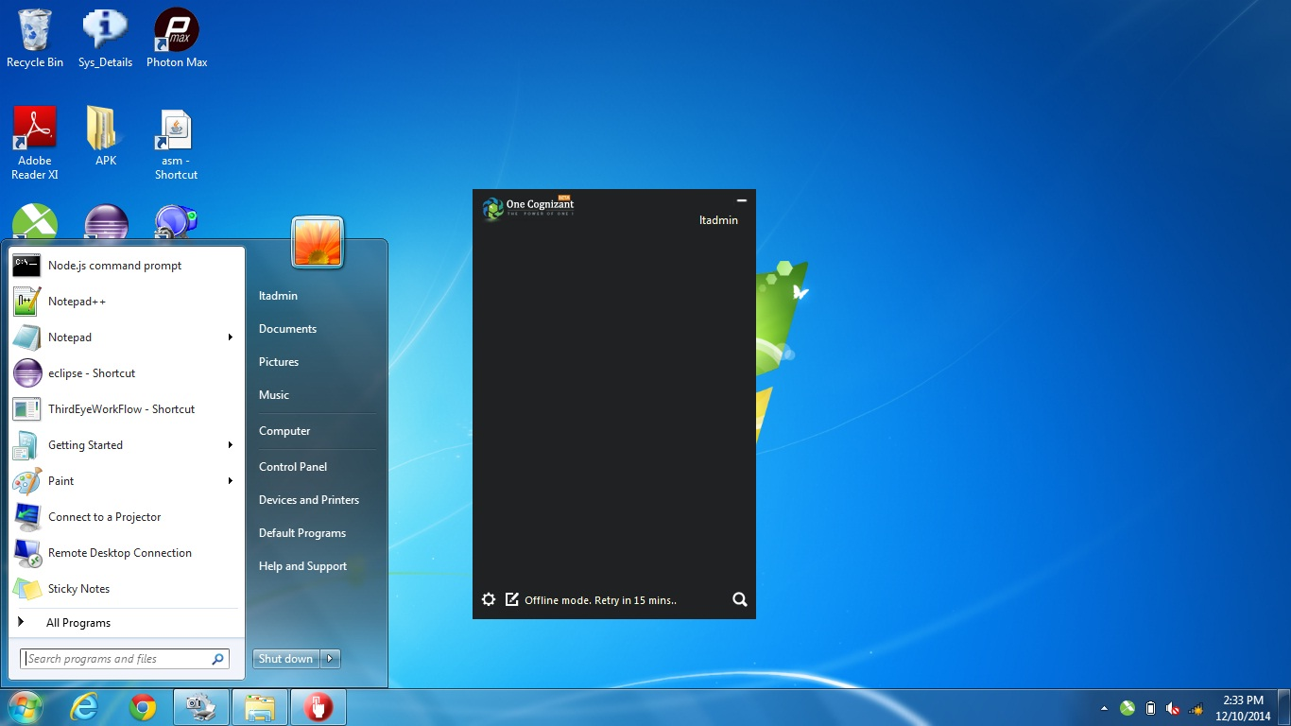

Navigate to the droneServer path.

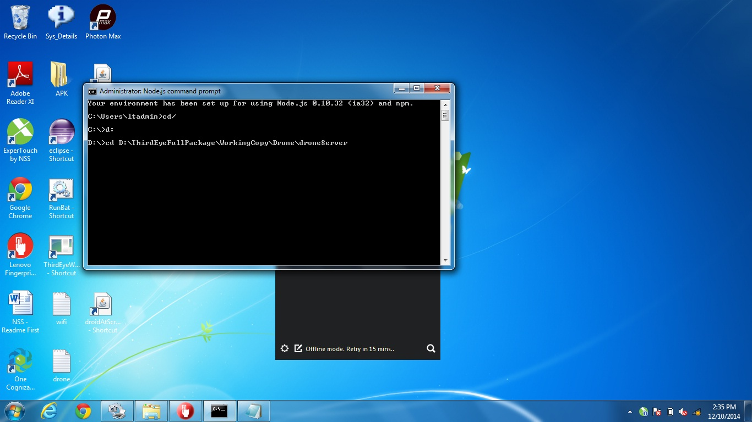

Run “node server.js”.

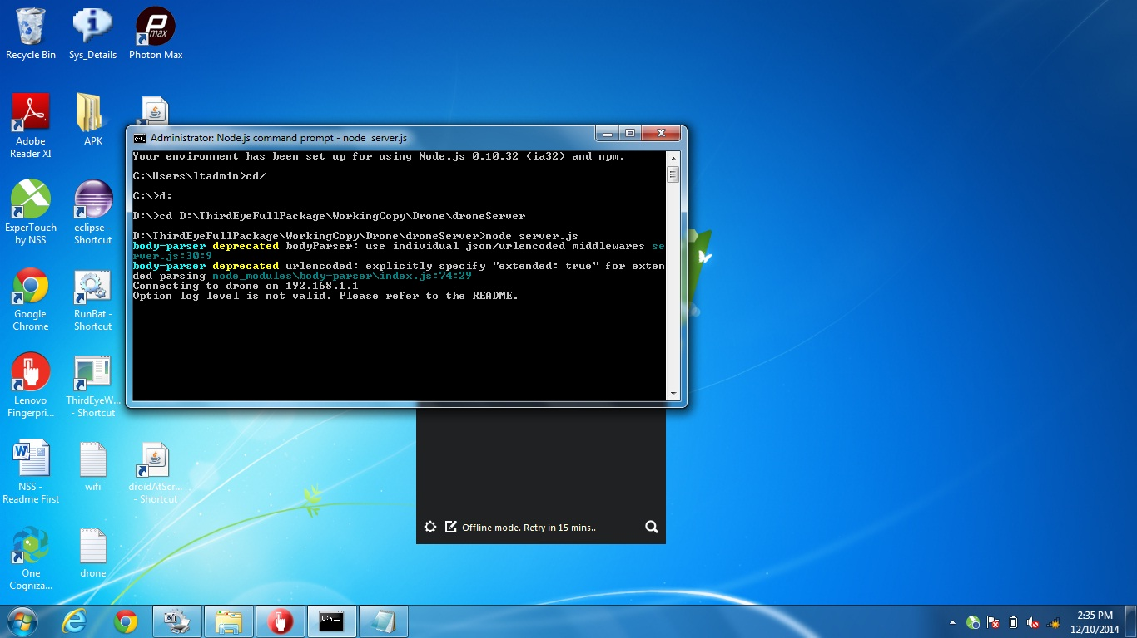

**Step-6:**

Once you started the node server, disable chrome web security in the following way.

Right click the Chrome icon, select properties and disable web security by appending the following.

“--disable-web-security”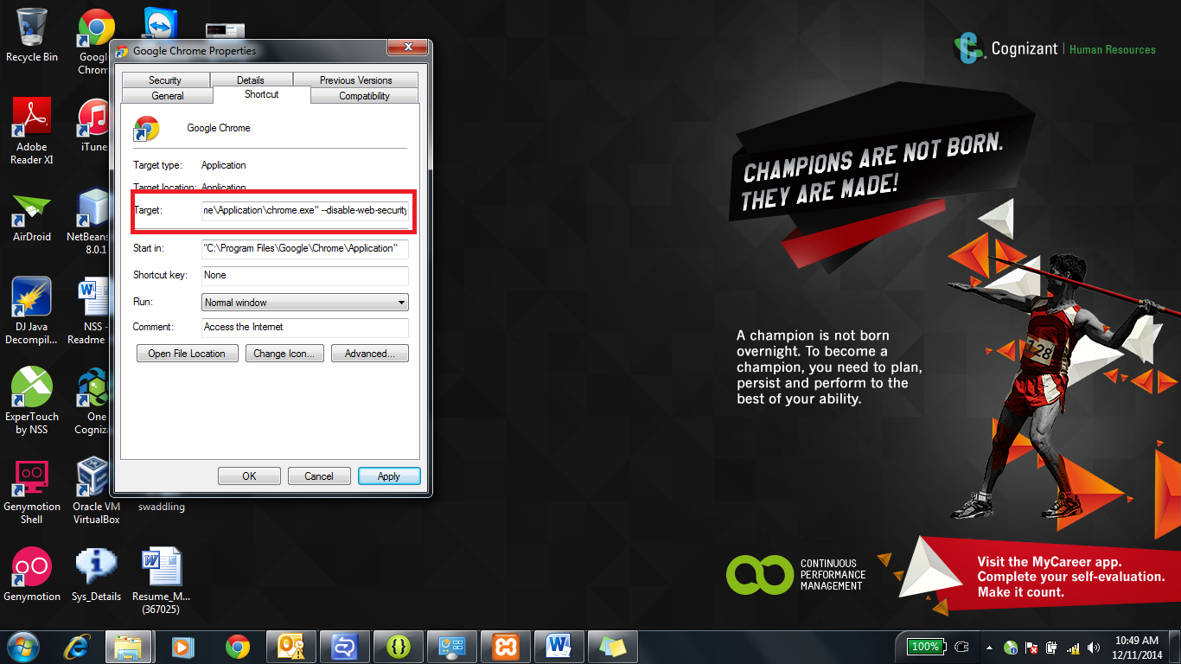

**Step-7:**

Open the Third Eye Dashboard web application. If the service is running and everything is appropriate, the available checklists will be shown as in the below snapshots.

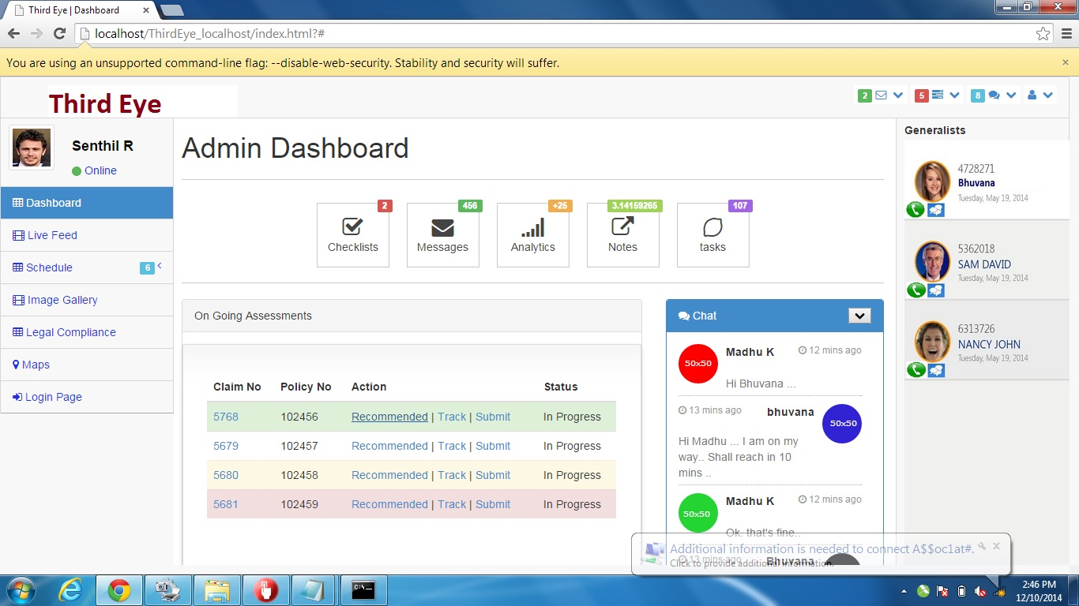

**Available Checklists:**

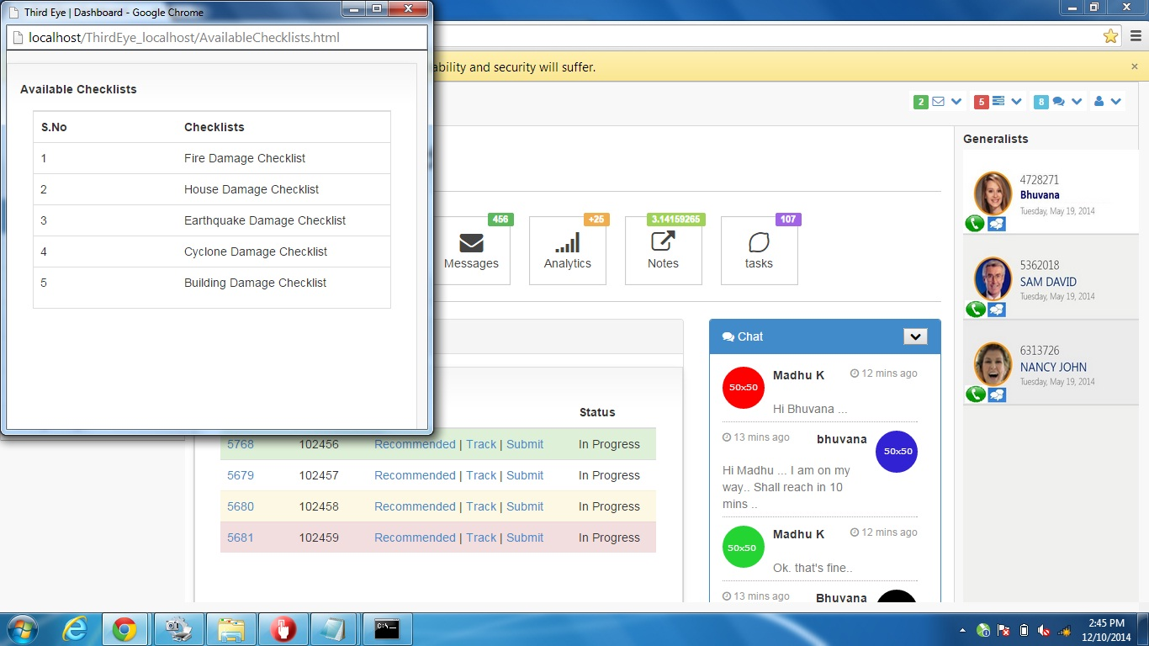

**Recommended Checklists:**

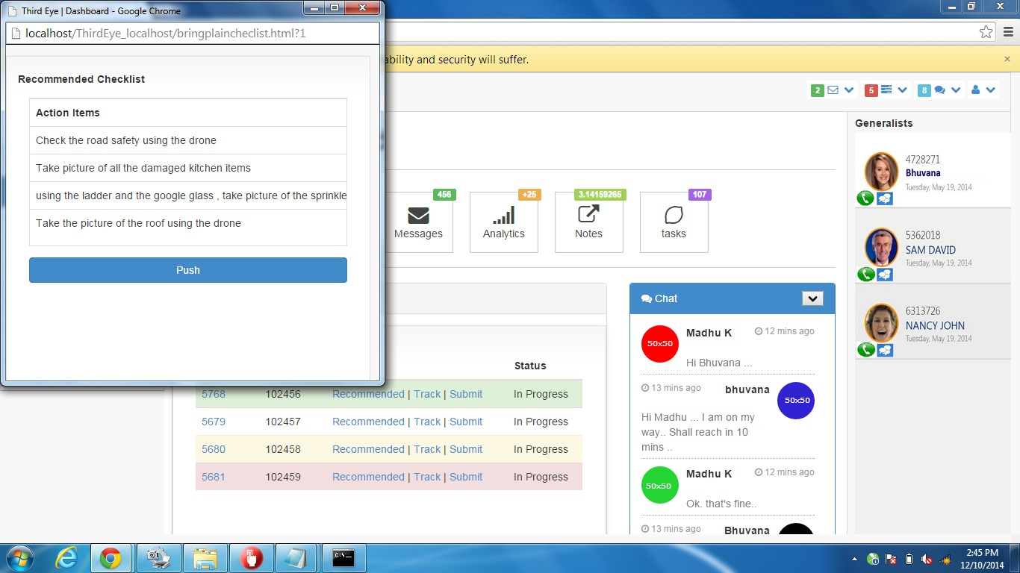

**Claim Details:**

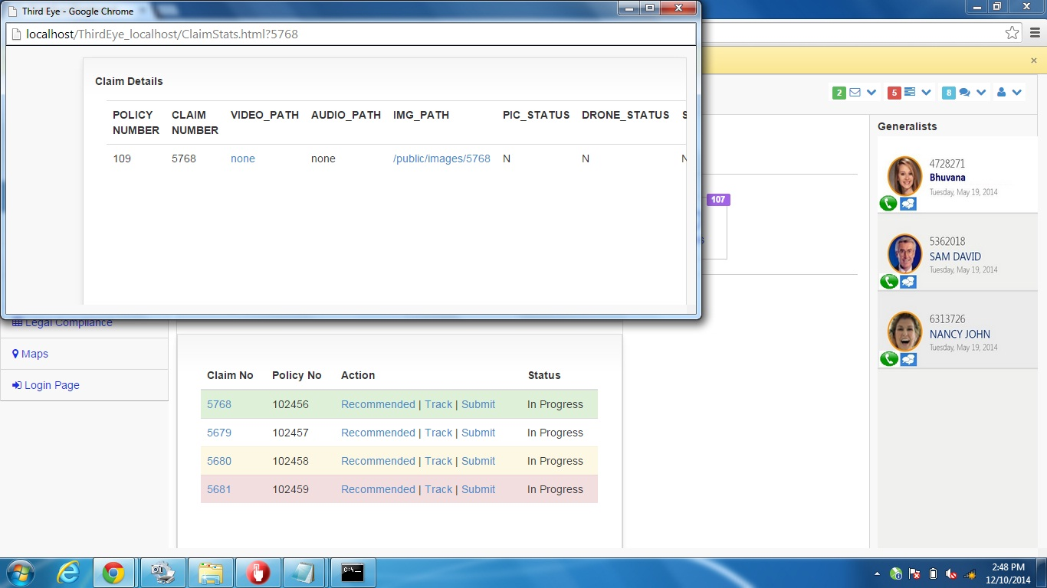

**Step-7:**

With the Google Glass ThirdEye app, capture the Drone and the Google Glass feed by choosing the appropriate options through tap gesture.

Refresh the Live Feed Page to see the Drone and the Google Glass feed based on option chosen.

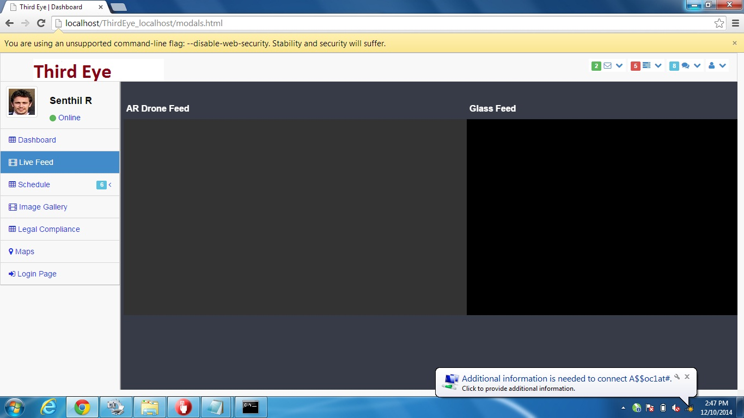

**Operating the drone in a standalone way (without Glass):**

Once you started the node server, for vertical orientation of drone, issue the following.

<http://192.168.1.2:3000/startv>

For horizontal orientation of drone, issue the following.

<http://192.168.1.2:3000/starth>